UNLOCKING THE ROSETTA STONE
For centuries visitors to Egypt had wondered about the meaning of the rows and rows of symbols they saw carved on tombs and monuments throughout the land. Were the symbols some kind of writing of the ancients? There had been many attempts to discover the secret of the symbols but no one had been successful.
THE ROSETTA STONE
It is some time in 1821AD. The midnight oil burns yet again in the study of Jean Francois Champollion as he contemplates the problem of the symbols. How to solve it? He has a copy of the mysterious Rosetta Stone which was discovered by French soldiers in Egypt in 1799AD. There are three different types of writing on it.
EGYPTIAN HIEROGLYPHICS: This is the name given to the mysterious symbols. The word hieroglyphics means sacred carvings.
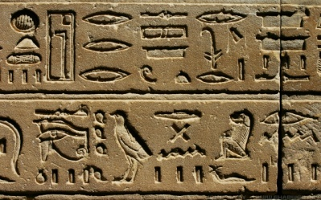
DEMOTIC SCRIPT: This was first designed as a simpler form of hieroglyphics. However, this form of writing had changed so much over the years that by the time it was used on the Rosetta Stone it looked nothing like the original.
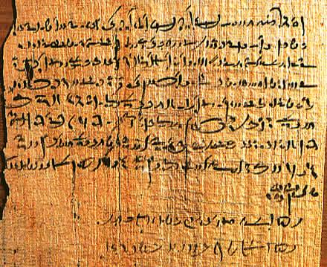
ANCIENT GREEK:
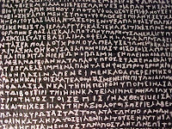 Greek script on the Rosetta Stone

UNLOCKING THE SECRET:
The Greek part of the Rosetta Stone had been deciphered by 1803. By comparing the Demotic part of the stone with the Greek it had been possible to work out what it means. But how to work out what the hieroglyphics mean?
A gem of an idea glowed in Jean’s mind. He had been carefully studying an obelisk (or stone column) from Philae, a small island located in the Nile River. Upon the obelisk is carved an interesting cartouche (the name of someone very important which is written in hieroglyphics and enclosed inside an oblong shape.)
He believed it bore the name of Ptolmis, a Pharaoh who ruled Egypt around 195BCE. The name of Ptolmis is also engraved on the Rosetta Stone.

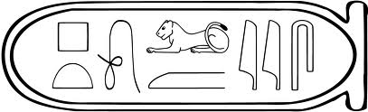 The cartouche of Ptolmis

Jean then investigated another cartouche carved upon the obelisk
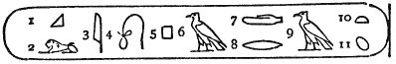
He was positive that it bore the name of one of the following very important women.
- Arsinai
- Kleopatra
- Pilatra
- Barenikat
Use the information in the cartouche of Ptolmis to decipher who the second cartouche belongs to.
Hint: Compare the hieroglyphs in each cartouche.

